Your task is to understand the glacier system, the glacier budget and glacial processes of weathering and erosion...
The glacier system
Use the Boardworks PowerPoint to complete your own systems diagram...
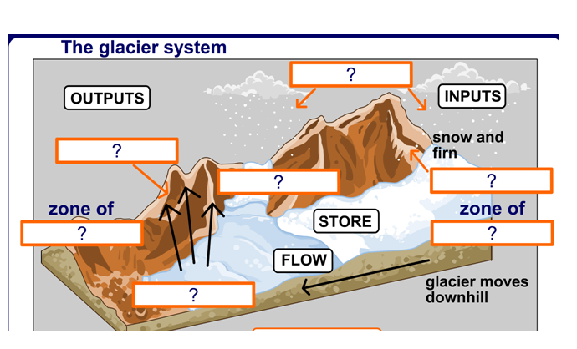
- Shade the inputs and outputs in different colours.
- Add an extra label to your diagram to show the snout of the glacier.
- Write definitions for:
The zone of accumulation:

- Why does accumulation dominate in the upper part of a glacier?
- Why does ablation dominate in the area near to the snout of the glacier?
The glacial budget
This is the balance between the inputs and the outputs. It varies from season to season and over a period of years...so the dividing line between the zones of accumulation and ablation changes... (see page 108)
a. Why is the budget described as positive in the winter?
b. Why is the budget described as negative in the summer?
watch this: http://www.bbc.co.uk/learningzone/clips/evidence-for-global-warming-glacial-retreat/1493.html
Over a longer period of time if winter snowfall begins to decrease year after year, and summer melting increases then glaciers will retreat. We are currently in a period of global warming and so it does appear that glaciers are retreating. Each summer, the surface ice cover in the Arctic Ocean is melting more and more while in the Antarctic bigger and bigger icebergs are calving from the Antarctic Ice Sheet.
(read more at http://www.bbc.co.uk/worldservice/news/2010/02/100226_iceberg_wt_sl.shtml )

Glacial Processes (p101)
- Describe the weathering process that dominates in glacial landscapes. (Include labelled diagrams!)
- Name the two processes of erosion that dominate in glacial landscapes. Describe how each one operates.
Extension:
How do glaciers move? http://www.geomorphology.org.uk/pages/education/alevel/coldenvirons/Lesson%208.htm
Read more about the glacier system and budget at http://www.geomorphology.org.uk/pages/education/alevel/coldenvirons/Lesson%206.htm

